T-V1475S vertical machining center
Technology Agreement

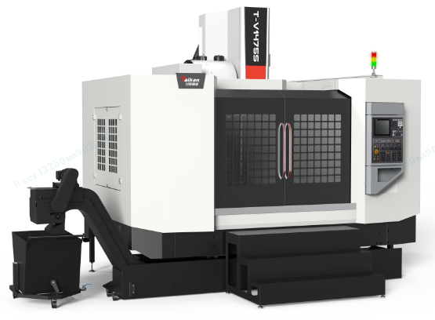
（The pictures are for reference only）
Party A（buyer）： | Represent：  date：
Party B（seller）： Shenzhen Genesis Machinery Co., Ltd. | Represent：  date：

Directory

1 Equipment technical description, parameters, and configuration 1
1.1. Equipment technical description 1
➢ The whole machine structure 1
➢ The foundation parts 2
➢ The spindle 2
➢ The balance device: 2
➢ Knife striking 2
➢ Tool magazine 2
➢ The screw 2
➢ Guide rails 2
➢ The lubrication system 3
➢ Chip removal 3
➢ CNC system 3
➢ Working conditions 3
1.2. Equipment Parameter and configuration 4
1.2.1. Basic Parameters 4
1.2.2. Standard configuration 6
1.2.3. Customer optional configuration 7
2 Core component brands 7
3 System main function table 8
4 Recommended oil and grease table 12
5 Quality assurance 14
6 Others 15

Equipment technical description, parameters, and configuration

Equipment technical description
T-V1475S vertical machining center is a medium-sized machine tool. With a workpiece each clamping cycle, it is capable of performing automatically and continuously various machining operations such as milling, drilling, boring, expanding, reaming, countersinking, tapping, and other processes. The machine tool is suitable for processing of various types of small and medium-sized batches of complex parts such as medium-sized boxes, plates, disks, valves, and shells.
- The whole machine structure: The structure of the whole machine is fixed column type and cross slide structure. The Y-axis of the machine tool adopts a four-guide guide rail design, which ensures heavy-load capacity during processing and ensure processing accuracy. The whole machine is fully enclosed for protection, as well as the machine tool has beautiful appearance and is easy to operate and maintain.
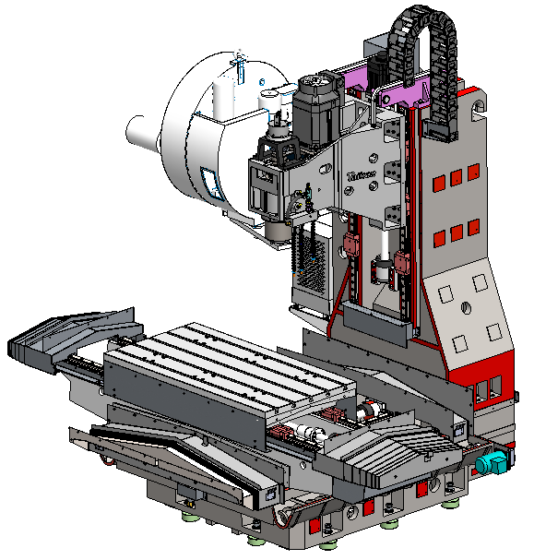
- The foundation parts: The basic large parts are made of high-quality resin sand molding and high-strength cast iron materials to ensure high rigidity and stable accuracy of the machine tool.
- The spindle: The spindle adopts a high-speed spindle unit from Taikan, coming standard with a belt-drive BT50-6000rpm spindle with high cutting efficiency, which reduces thermal deformation of the spindle.
- The front end of spindle adopt labyrinth design with an air curtain protection function to prevent cutting fluid from entering the spindle bearing.
- The spindle has a central air blowing function, equipped with an automatic constant-temperature circulating water cooling device, which reduces the temperature rise and thermal deformation of the spindle and maintains high machining accuracy.
- The balance device: The spindle box movement (Z-axis) is equipped with a counterweight device with a central guided design. Even when moving at high speed, the counterweight will not shake. The precise ratio of counterweight to spindle box weight results in optimal machining characteristics. And the Z-axis drive motor has good load characteristics.
- Knife striking: Adoption of market-proven and mature air pressure knife striking ensures the stability and reliability of each knife striking, protects the spindle and improves the overall performance of the machine.
- Tool magazine: Tool magazine adopt BT50-24T arm-type tool magazine, featuring reliable quality and stable performance
- The screw: The three-axis feeding adopts a direct connection drive between the motor and the high-precision ball screw, and the large-diameter C3 grade ball screw is mounted by pre-stretching to further improve the transmission rigidity and positioning accuracy.
- Guide rails: X and Y-axis guide rails adopt 45# roller linear guide rails to load, featuring high rigidity, minimal noise, and reduced friction. Z-axis guide rails adopt 55# roller linear guide rails, featuring high rigidity, good vibration absorption, and can carry greater cutting force.
- The lubrication system: The guide rails and screws of the machine tool adopt a timed and quantitative lubrication system, which can adjust the oil supply cycle and amount of each lubrication point, and realize fully automatic centralized lubrication through electrical system control.
- Chip removal: The chip removal of the machine tool adopts a built-in double screw conveyor and a front chain plate type chip conveyor. It has a high degree of automation and reduces manual cleaning time. It is automated, user-friendly and highly efficient.
- The water tank of the machine adopts the structure of multi-layer filtration system to provide good cutting fluid for workpiece machining.
- CNC system: The machine is equipped with the high-performance FANUC 0i-MF PULS (5) CNC system, which guarantees the stability of the machine control, as well as the CNC machining functions and auxiliary functions requested by the user.

Working conditions
- Three-phase AC power supply: 380V±5%; 50Hz±1Hz;
- Ambient temperature: need to keep the ambient temperature 17 ~ 25 ℃, If the precision requirements of processing parts are not high, can be relaxed to 5 ~ 40 ℃. Storage or transport temperature -20～60℃
- Room temperature change: The ambient temperature changes within ±2°C within 24 hours.
- Relative humidity: Within 75% (no condensation);
- Altitude: Below 1000m;
- Vibration: Below 0.2G；
- Foundation requirements: bearing capacity above 50KN/m²；
- Keep away from light sources, vibration sources, and heat sources, and away from high-frequency generators, dischargers, welding machines, etc. to avoid electrical interference that may cause machine tool NC system malfunctions.
- If the voltage in the area of use is not stable, the machine tool should be equipped with a regulated power supply.
- The machine tool should have reliable grounding: the grounding wire is a copper wire, the wire diameter should not be less than 16 mm ², and the grounding resistance should be less than 4Ω.
- In order to ensure the normal working performance of equipment, if the air compressed by the air source does not meet the cleanliness requirements, an air source purification device should be equipped before the machine tool air intake.

Equipment Parameter and configuration

Basic Parameters
Name |  |  | Unite | Parameter | Remark
Stroke range | Worktable stroke(X-axis) |  | mm | 1400
Stroke range | Saddle stroke(Y-axis) |  | mm | 750
Stroke range | Spindle box stroke(Z-axis) |  | mm | 650
Stroke range | The distance from the spindle end face to the worktable |  | mm | 100～750
Stroke range | Distance from spindle center to column guide |  | mm | 821
Worktable | Worktable size |  | mm | 1500*750
Worktable | Worktable load |  | Kg | 1400
Worktable | T-shaped slot (number of slots-slot width*spacing) |  | mm | 5-18*150
Spindle | Motor power (rated/short time) |  | kw | 15/18.5
Spindle | Motor torque (rated/short time) |  | N.m | 143/191
Spindle | rotation speed range |  | r/min | 50～6000(Belt）
Spindle | Spindle diameter |  | mm | φ155
Spindle | Handle specifications |  | / | BT50
Spindle | blind rivet specification |  | / | P50T-I（MAS403）
Guide rail | X-axis |  | mm | 2-45 roller
Guide rail | Y-axis |  | mm | 4-45 roller
Guide rail | Z-axis |  | / | 2-55 roller
Tool magazine | Tool magazine capacity |  | T | 24
Tool magazine | tool weight |  | kg | 15
Tool magazine | Tool length |  | mm | 300
Tool magazine | Maximum diameter (full tool/adjacent empty tool) |  | mm | Φ105/Φ210
Drive | Screw X/Y/Z |  | mm | 50*12/50*12/50*10
Drive | Motor power X/Y/Z |  | kw | 3.0/3.0/3.0
Speed | Cutting feed speed range |  | mm/min | 1-10000
Speed | Fast-moving speed of X/Y/Z-axis |  | m/min | 24/24/20
Machine tool accuracy | Positioning accuracy (X/Y/Z) |  | mm | 0.015 | GB/T18400.4  （total Stroke）
Machine tool accuracy | Repeated positioning accuracy（X/Y/Z） |  | mm | 0.008 | GB/T18400.4  （total Stroke）
Other | Z-axis counterweight |  | / | Have
Other | CNC system |  |  | FANUC 0i-MF Plus(5)
Other | Gas source | flow | L/min | 280（ANR)
Other | Gas source | air pressure | MPa | 0.6∼0.8
Other | Equipment capacity |  | KVA | 40
Other | Cooling box volume |  | L | 400
Other | Machine tool appearance dimensions (length*width*height) |  | mm | 3684*2845*3285 | Without chain row size
Other | Main unit weight (approx.) |  | Kg | 10600
#: The appearance dimensions of the machine tool may change due to configuration without further notice.

Standard configuration
No | Name | Amount | Remark
1 | FANUC 0i-MF Plus(5) CNC system | 1
2 | Operation panel | 1
3 | Pneumatic system | 1
4 | Air gun | 1
5 | Automatic lubrication system | 1
6 | Spindle water cooling system | 1
7 | Workpiece cooling system | 1
8 | Built-in spiral chip conveyor | 2
9 | Front chain plate chip conveyor + chip catcher trolley | 1
10 | Full protection | 1
11 | Three-color light | 1
12 | Lighting devices | 1
13 | Basic installation kit | 1
14 | Randomized sets of standard technical documents | 1
15 | BT50-24T arm-type tool magazine | 1

Customer optional configuration
No | Name and specification | Selection | Remark
1
2
3
Note: If you select this configuration, mark √ in the corresponding item box

Core component brands
Core component brands and specification
No | Component name | Brands | Precision grade
1 | Controller systems | FANUC 0i-MF Plus(5) system | High-performance grade
2 | Spindle unit | Taikan | High-Precision grade
3 | Three-axis bearings | Japan NSK/GermanyFAG | P4 grade
4 | Three-axis screw | Taiwan PMI/Hiwin | C3 grade
5 | roller linear guide rails | Taiwan PMI/Hiwin | P grade
6 | Main electrical components | French Schneider
7 | 24T arm-type tool magazine | Taikan
8 | Main pneumatic components | Japan SMC
9 | Servo Driver | Japan FANUC
Note: When supply is insufficient, other brands of products will be used instead, but the quality and grade will not be lower than the listed configurations.

System main function table
（Some functions need to be combined with the configuration of the host to be realized）
No | Function | clarification | Remark
1 | Number of control paths | 1
2 | Maximum total number of control axes (feed axis + spindle) | 6
2 | Maximum number of feed axes | 5
2 | Maximum number of spindles | 1
3 | Control the number of axes simultaneously | 4
4 | Display unit | 10.4＂
5 | Servo HRV control | High-speed, high-precision servo control
6 | Program capacity | 2M
7 | I/O Link | 1024/1024
8 | Automatic data backup | Backup of machine data
9 | Memory Card Edit/Run | DNC online processing
10 | Program folder management | Functions for using macro programs and machining programs
11 | FSSB High-speed rigid tapping | Reduced rigid tapping time and errors
12 | Intelligent backlash compensation | Backlash compensation
13 | PMC axis control
14 | Data transfer via embedded Ethernet | Data transfer function via Ethernet
15 | USB transfer program to CF card | Data transfer function
16 | Spindle Intelligent load meter | Monitoring spindle current and other status
17 | Spindle HRV control | High-speed, high-precision servo control
18 | AI contour controlⅠ | Pre-reading of program segments within 40 segments (others are not optional)
19 | Bell-shaped acceleration and deceleration before read-ahead interpolation
20 | Intelligent overlap | Achieving reduction of cycle times for machining parts
21 | Pre-processing preparation support function
22 | Imperial/Metric Conversion | Conversion of machine tool units
23 | HRV3 control | High-speed, high-precision servo control
24 | Flexible feed gear | Arbitrary DMR
25 | Minimum setting unit（0.0001mm、0.0001deg、0.00001 inch） | The smallest unit of the system
26 | Mirror | Each axis
27 | Rigid tapping retraction | Rigid tapping retraction
28 | Buffer register | The system can cache data
29 | Positioning
30 | Linear interpolation | Linear machining function
31 | Arc interpolation | Arc processing function
32 | Spiral interpolation | Spiral processing function
33 | Flip of the rotary axis | Flip of the rotary axis
34 | Arbitrary Angle Chamfer/Corner R | Arbitrary Angle Chamfer/Corner R
35 | Fixed circulation for drilling | Fixed circulation for drilling
36 | No block reference point setting | No block reference point setting
37 | Automatic cornering magnification | Automatic corner processing ratio control
38 | Scaling | Scaling
39 | Plane selection | G17 G18 G19
40 | Programmable mirror | Programmable mirroring of each axis
41 | Single program segment | Single-segment of the program can be executed
42 | Program restarts | After the program is temporarily interrupted, it can be restarted
43 | Tool diameter, tool nose radius compensation | Tool parameter compensation
44 | Tool life management | Tool life management
45 | Tool life management extension | Tool life management extension
46 | Spindle stops accurately
47 | Position tracking | Position tracking
48 | Abnormal load detection | Abnormal load detection for each axis
49 | Position switch | Program protection function
50 | Backstage Editing | Program editing can be performed in edit mode
51 | National language display function | System operation interface language display function 10 kinds
52 | Self-diagnosis function | Can monitor machine tool status
53 | Help function | Please refer to System Alarm
54 | Nano interpolation | Nano interpolation
55 | Workpiece coordinate system | G52~G59
56 | Absolute/Incremental Instructions | Can be mixed in the same program section
57 | Fault diagnosis | Can find current machine tool fault conditions
58 | Clear screen | Manual or automatic clearing of the screen
59 | Power consumption monitoring | Can check the power consumption of machine tools

Recommended oil and grease table
（Refer to this table according to the actual configuration of the equipment）
Lubrication part |  | Amount | Recommended oil |  | Remark
 |  | Amount | Room temperature 10～40℃ | Room temperature 5～10℃ | Remark
Guide screw | Oil lubrication | 2-4L | Guide rail oil 68# | Guide rail oil 32# | 1. Check before work every day. When warning signs appear, please refuel.  2. Pay attention to changing the oil when the temperature is low.  3. When using canned grease, the brand of canned grease needs to be consistent with the manufacturer of the oil injector.
Guide screw | Grease lubrication | 0.7-0.8L | Lithium grease 000#
Spindle screw cooler | Water cooler | 15-35L | BASF G48 Antifreeze（No media is allowed to be added） |  | 1. Check before work every day. When the warning signal appears, please add antifreeze or refuel.  2. Pay attention to changing the oil when the temperature is low.
Spindle screw cooler | Oil cooler | 20-40L | 10# Great Wall Spindle oil | 5# Great Wall Spindle oil
Hydraulic station |  | 25L | Hydraulic oil HV32# | Hydraulic oil HV20# | 1. Inspect daily before work and replace the oil with new oil every year.  2. Pay attention to changing the oil when the temperature is low.
Booster cylinder |  | 0.1-0.2L | Hydraulic oil 32# | Hydraulic oil 20# | 1. Check before work every day and refill the oil cup when it is only 1/3 full.  2. Pay attention to changing the oil when the temperature is low.
Cutting fluid |  | 100-350L | According to the workpiece material and processing conditions, select the appropriate cutting fluid (based on the actual oil tank capacity on site)) |  | When the room temperature is lower than 5℃, please check whether there is ice in the fuel tank before starting the machine.
Fourth axis |  | 0.8~1L | Gear Oil 150# | Gear Oil 100# | 1. Check daily before work and replace with new oil every six months.  2. Pay attention to changing the oil when the temperature is low.
Tool changing arm system |  | 7L | Gear Oil 100# | 15W-40 Antifreeze diesel engine oil | 1. Check daily before work, and replace with new oil every 2400 working hours or every six months.  2. Pay attention to changing the oil when the temperature is low.

Quality assurance
- The quality guarantee period is 12 months from the date of final acceptance.
- During the warranty period, if the buyer uses the equipment or machine tool under normal conditions in accordance with the instruction manual, the seller will be responsible for any damage caused by defects in factory design or manufacturing. During the above warranty period, if there is a problem with the equipment, the seller will make correction suggestions to the buyer; if the buyer still cannot solve the problem according to the seller's instructions and system description, the seller shall dispatch a maintenance engineer free of charge within 2 working days after receiving the buyer's notice. Arrive at the buyer's factory.
- During the warranty period, the seller shall provide the buyer with timely maintenance services and necessary spare parts free of charge. It is verified that the failure loss caused by the buyer's improper operation, unreasonable cutting parameter selection or self-disassembly and modification, and other non-manufacturing quality reasons, as well as the damage to the appearance or interior of the machine tool caused by excessive storage time, are not covered by the above warranty, and the buyer must pay for relevant maintenance cost.
- After the warranty period, the seller will maintain the machine tool for life and provide free online services and technical guidance. Provide timely supply of spare parts to buyers at favorable prices. If it is necessary to send someone to the site for repairs, the corresponding fees will be charged according to the seller's standards.

Others
1. Matters not covered in this agreement shall be resolved through negotiation between the two parties.
2. This agreement is an attachment to the contract and will take effect simultaneously with the contract after it is signed by Party A and Party B.
3. This agreement is made in duplicate, with Party A and Party B each holding one copy.

